360 Degree Rotating Blade Windmill.

[Drawings of a 360-degree rotating blade windmill]

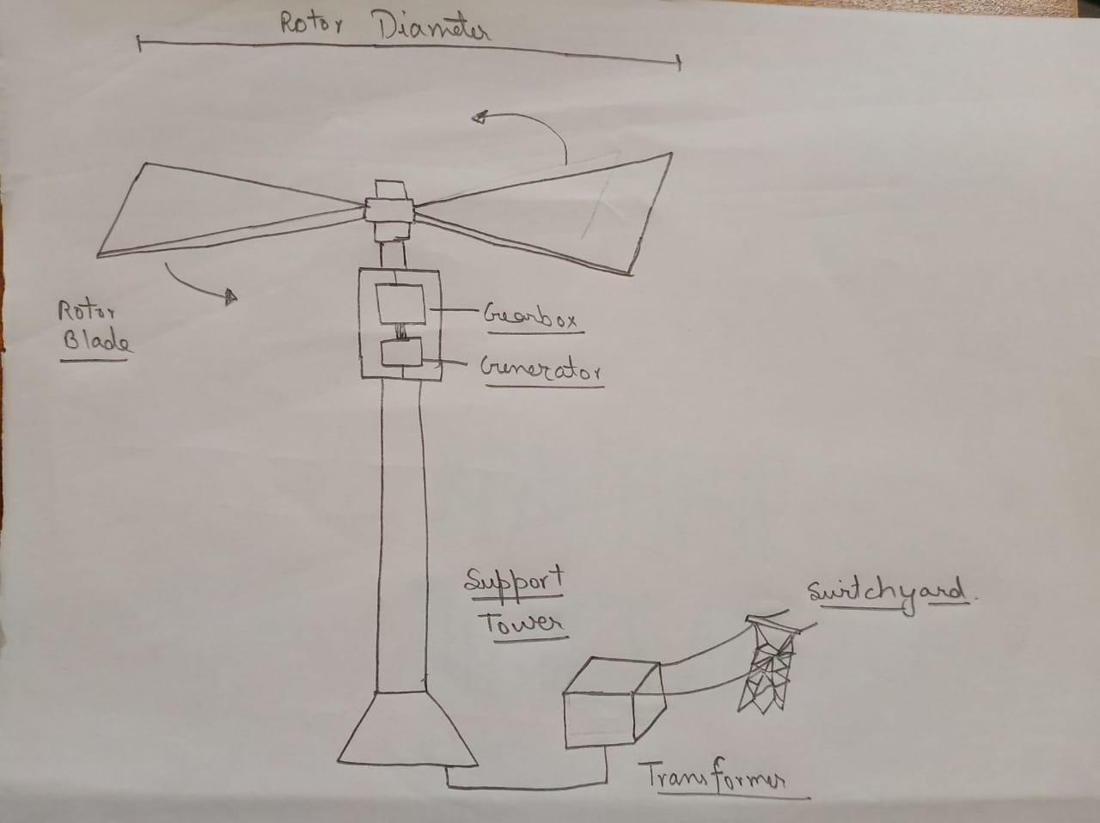

[Sketch of a 360-degree rotating blade]

360 Degree Rotating Blade Windmill.

***Abstract* — This patent application introduces an inventive vertical windmill system designed to harness wind energy efficiently with bi-directional blade rotation. Representing a transformative approach in wind energy technology, the vertical turbine is securely mounted within a vertical pole, enhancing its durability and performance. The hallmark of this innovation is the unique blade rotation mechanism, reminiscent of an inverted fan, which allows the windmill to exploit wind energy from all directions.**

***Keywords — 360-degree rotating blade windmill, Wind turbine technology, Renewable Wind energy generation, Blade rotation mechanism, Environmental sustainability, Wind power innovation, Fossil fuel reduction, Energy sustainability, Eco-friendly wind turbines, green technology, Wind energy patent, Sustainable energy generation.***

***Introduction: -***

The growing demand for clean, sustainable energy sources has driven innovations in the field of wind energy. Traditional horizontal-axis wind turbines have played a significant role in harnessing wind power, but they are constrained by their reliance on consistent and unidirectional wind flow. In contrast, our revolutionary vertical windmill system represents a fundamental departure from conventional designs.

At the core of our design is a vertically oriented wind turbine, securely housed within a robust pole structure. The defining feature of this invention lies in the blade rotation mechanism. Instead of conventional clockwise or counterclockwise rotation, our windmill's blades operate in a bi-directional manner, akin to an inverted fan. This novel approach allows the windmill to capture wind energy from any direction, a characteristic that dramatically enhances energy generation efficiency.

Furthermore, our innovative windmill incorporates a total of eight blades, strategically positioned to maximize the capture of air and wind energy. This expanded air capture area ensures the windmill remains productive even in conditions of variable or turbulent wind flow. By enabling optimal energy production, regardless of wind direction, this design stands as a substantial advancement in wind energy technology, providing a more reliable and efficient means of renewable energy generation. Use the enter key to start a new paragraph. The appropriate spacing and indent are automatically applied.

***Annexure: -***

Winds are caused by the uneven heating of the atmosphere by the sun, the irregularities of the earth's surface, and rotation of the earth. The earth’s surface is made of different types of land and water. These surfaces absorb the sun’s heat at different rates, giving rise to the differences in temperature and subsequently to winds. During the day, the air above the land heats up more quickly than the air over water. The warm air over the land expands and rises, and the heavier, cooler air rushes in to take its place, creating winds. At night, the winds are reversed because the air cools more rapidly over land than over water. In the same way, the large atmospheric winds that circle the earth are created because the land near the earth's equator is heated more by the sun than the land near the North and South Poles. Humans use this wind flow for many purposes: sailing boats, pumping water, grinding mills, and generating electricity. Wind turbines convert the kinetic energy of the moving wind into electricity. Wind Energy, like solar is a free energy resource. But is much more intermittent than solar. Wind speeds may vary within minutes and affect the power generation and in cases of high speeds- may result in overloading of generator. Energy from the wind can be tapped using turbines.

Setting up of these turbines needs little research before being established. Be it a small wind turbine on a house, a commercial wind farm or any offshore installation, all of them, at first, need the Wind Resource to be determined in proposed site. The Wind Resource data is an estimation of average and peak wind speeds at a location based on various meteorological. The next step is to determine access to the transmission lines or nearest control center where the power generated from the turbines can be conditioned, refined, stored, or transmitted. It is also necessary to survey the impact of putting up wind turbines on the community and wildlife in the locality. If sufficient wind resources are found, the developer will secure land leases from property owners, obtain the necessary permits and financing; purchase and install wind turbines. The completed facility is often sold to an independent operator called an independent power producer (IPP) who generates electricity to sell to the local utility, although some utilities own and operate wind farms directly.

***Idea: -***

A 360-degree rotating blade windmill is a type of windmill that has blades that can rotate in all directions. This allows the windmill to capture wind from all directions, which makes it more efficient than traditional windmills, which can only capture wind from one direction.

A 360-degree rotating blade windmill consists of the following components:

* Blades: The blades are the most important part of a windmill. They are responsible for capturing the wind and converting it into rotational energy. The blades of a 360-degree rotating blade windmill are typically made of a lightweight and durable material, such as carbon Fiber or fiberglass.
* Rotor: The rotor is the mechanism that rotates the blades. It is typically made of a strong and lightweight material, such as aluminium or steel.
* Generator: The generator is the device that converts the rotational energy of the rotor into electrical energy. It is typically mounted on the rotor hub.
* Tower: The tower is the structure that supports the windmill. It is typically made of steel or concrete.

The blades of a 360-degree rotating blade windmill are mounted on platform. The platform is connected to the rotor hub, which is connected to the generator. As the wind blows, the blades rotate the rotor, which in turn rotates the generator. The generator converts the rotational energy of the rotor into electrical energy. The electrical energy generated by the windmill can be used to power homes, businesses, or other facilities. It can also be stored in batteries for later use.

Advantages of 360-Degree Rotating Blade Windmills

* Increased efficiency: 360-degree rotating blade windmills are more efficient than traditional windmills because they can capture wind from all directions. This means that they can generate more electricity, even in areas with variable wind conditions.
* Reduced noise and vibration: 360-degree rotating blade windmills are quieter and produce less vibration than traditional windmills. This is because the blades can rotate smoothly in all directions.
* Reduced maintenance requirements: 360-degree rotating blade windmills are easier to maintain than traditional windmills. This is because the blades are not mounted on a fixed axis, which makes them less susceptible to damage.
* Increased lifespan: 360-degree rotating blade windmills have a longer lifespan than traditional windmills. This is because the blades can rotate smoothly in all directions, which reduces wear and tear.
* Powering homes and businesses: 360-degree rotating blade windmills can be used to power homes and businesses in both urban and rural areas.
* Generating electricity for the grid: 360-degree rotating blade windmills can be used to generate electricity for the grid, which can help to reduce our reliance on fossil fuels.
* Powering water pumps and other equipment: 360-degree rotating blade windmills can be used to power water pumps and other equipment in remote areas where there is no access to the grid.

The main advantage of a 360-degree rotating blade windmill over traditional windmills is its increased efficiency. Traditional windmills can only capture wind from one direction, while 360-degree rotating blade windmills can capture wind from all directions. This means that 360-degree rotating blade windmills can generate more electricity, even in areas with variable wind conditions.

In addition to increased efficiency, 360-degree rotating blade windmills have several other advantages over traditional windmills. They are quieter, produce less vibration, and are easier to maintain. They also have a longer lifespan.

There are several variables that are necessary for my invention to be covered, including:

* The number of blades: The number of blades on a 360-degree rotating blade windmill will affect its efficiency and performance. A windmill with more blades will be more efficient, but it will also be more expensive to build and maintain.
* The shape of the blades: The shape of the blades will also affect the windmill's efficiency and performance. A windmill with blades that are optimized for capturing wind from all directions will be more efficient than a windmill with blades that are designed for capturing wind from one direction.
* The materials used to build the windmill: The materials used to build the windmill will affect its weight, cost, and lifespan. A windmill made of lightweight and durable materials will be more expensive to build, but it will also have a longer lifespan.
* The control system: The control system is responsible for managing the rotation of the blades and ensuring that the windmill operates safely and efficiently. A sophisticated control system will be more expensive to develop and implement, but it will also improve the performance and reliability of the windmill.

##### Acknowledgments

I would like to extend my deepest appreciation to all those who played an integral role in the successful patenting of the '360-Degree Windmill' innovation. This achievement would not have been possible without the collaborative efforts of our dedicated team. I want to express my gratitude to My team, whose creativity and expertise were pivotal in developing this groundbreaking technology. I am also thankful for the support and guidance received from My teacher JAIBIR SINGH SIR throughout the patent application process. This patent represents a significant milestone, and I am excited about the positive impact it can have on the renewable energy sector.

##### Conclusion

In conclusion, this patent application represents a significant step forward in the field of wind energy generation. The 360-degree rotating blade windmill technology described herein offers a unique and revolutionary approach to harnessing wind power with improved efficiency and environmental sustainability.

The ability to capture wind energy from all directions without the need for wind tracking systems is a substantial breakthrough, enabling greater flexibility in wind turbine placement and significantly increasing energy output. This innovation has the potential to enhance the reliability and cost-effectiveness of wind energy systems, making wind power a more viable and attractive source of renewable energy.

Furthermore, the application of this technology has far-reaching implications for addressing climate change and reducing our dependence on fossil fuels. By maximizing wind energy capture and minimizing the environmental impact of wind farms, we are taking substantial strides towards a more sustainable and eco-friendly future.

In essence, this 360-degree rotating blade windmill technology holds the promise of revolutionizing the renewable energy landscape, and we look forward to seeing its real-world applications and benefits materialize. We are committed to advancing this innovation, and we anticipate that the patented technology will contribute significantly to a greener and more sustainable future for generations to come.

##### References

1. Google Patents – Windmill patents, Generator, Blade etc.
2. Indian Patent Office (IPO).